Chapter 7: Designing Documents and Web Sites

Part 1. For each of these, answer the questions; then if applicable find a place in your text where you see it exhibiting those design features. Write down the page or section number; you’ll present to the class a few of the design elements you’d like to discuss (for either good or bad reasons).

- Chapter 7 identifies five goals of document design. One goal is to make a good impression on readers. What are two other goals mentioned in the chapter? How does your text exhibit these?

- Chapter 7 discusses four basic principles for designing effective documents and Web sites. One is contrast. What are the other basic principles discussed in the chapter, and where/how does your text exhibit them?

- What is chunking? queuing? filtering? leading? Try to find an example of each in your text.

- Under “Page Layout” and starting with “White Space,” go through every blue heading and be able to define the term and find an instance of it used either effectively or ineffectively in your document.

- How are Titles and Headings treated in your text?
- How are “other design features” incorporated?

OVERALL: what are the top three design features you like in your text? What would you suggest needs improvement, if anything? Be prepared to discuss with the class.

Part 2. Using the text below, work on the document design. First, create a small thumbnail sketch on paper, thinking about what you would emphasize and why. Then move to MSWord. Go to the page with the Tech Tips, and add screens, borders, and text boxes. What are you choosing to emphasize and why?

Here's the story behind Black History Month — and why it's celebrated in February
Every February, the U.S. honors the contributions and sacrifices of African Americans who have helped shape the nation. Black History Month celebrates the rich cultural heritage, triumphs and adversities that are an indelible part of our country's history.
This year's theme, Black Health and Wellness, pays homage to medical scholars and health care providers. The theme is especially timely as we enter the third year of the COVID-19 pandemic, which has disproportionately affected minority communities and placed unique burdens on Black health care professionals.
"There is no American history without African American history," said Sara Clarke Kaplan, executive director of the Antiracist Research & Policy Center at American University in Washington, D.C. The Black experience, she said, is embedded in "everything we think of as 'American history.' "

First, there was Negro History Week […] It was Carter G. Woodson, the "father of Black history," who first set out in 1926 to designate a time to promote and educate people about Black history and culture, […] Woodson envisioned a weeklong celebration to encourage the coordinated teaching of Black history in public schools. He designated the second week of February as Negro History Week and galvanized fellow historians through the Association for the Study of Negro Life and History, which he founded in 1915. (ASNLH later became ASALH.) The idea wasn't to place limitations but really to focus and broaden the nation's consciousness.
"Woodson's goal from the very beginning was to make the celebration of Black history in the
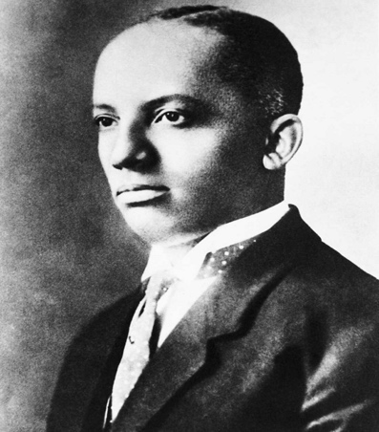
field of history a 'serious area of study,' " said Albert Broussard, a professor of Afro-American history at Texas A&M University. The idea eventually grew in acceptance, and by the late 1960s, Negro History Week had evolved into what is now known as Black History Month. Protests around racial injustice, inequality and anti-imperialism that were occurring in many parts of the U.S. were pivotal to the change.
Colleges and universities also began to hold commemorations, with Kent State University being one of the first, according to Kaplan. Fifty years after the first celebrations, President Gerald R. Ford officially recognized Black History Month during the country's 1976 bicentennial. Ford called upon Americans to "seize the opportunity to honor the too-often neglected accomplishments of Black Americans in every area of endeavor throughout our history," History.com reports.

Why February was chosen as Black History Month: February was chosen primarily because the second week of the month coincides with the birthdays of both Abraham Lincoln and Frederick Douglass. Lincoln was influential in the emancipation of slaves, and Douglass, a former slave, was a prominent leader in the abolitionist movement, which fought to end slavery.
Lincoln and Douglass were each born in the second week of February, so it was traditionally a time when African Americans would hold celebrations in honor of emancipation, Kaplan said. (Douglass' exact date of birth wasn't recorded, but he came to celebrate it on Feb. 14.) Thus, Woodson created Negro History Week around the two birthdays as a way of "commemorating the black past," according to ASALH. […]

